محمد ابراهيم عبدالحميد محمود

Software final report

Customer proof: -

Blue moon is a Travel agency providing all types of tourism services

* Incoming and Outgoing tourism packages
* extensive and unique trips
* Ticketing
* Cruise Trips
* Hajj and Umrah packages For all tourists over Egypt.
* All Trips arrangements are prepared by the agency from Transports to Booking hotels  
   The main goal is to provide an interactive interface facilitates dealing with the customers of the agency to obtain the most benefit from the marketing view which also saves a lot of time and effort of providing all services and offers to the users and even booking online.

Software Model: -

Incremental model :

We used this model because of the range of: -  
 1- the project which can be said to be moderate from the size sight.  
 2- from the risks sight the project isn’t high risky.  
 3- The model is flexible to the customer change of requirements or needs.  
 4- The cyclic unit testing after each increment and the integration test before delivering the whole product  
 So we used the incremental model base on its properties like short lifecycle, simplicity and durability as it assures the customer is interfered in the whole process as a main part as he should send a feedback after each delivered increment through a direct communication with the team leader and can ask for adjustments or edit his requirements or even adds other requirements in the middle of the process .  
 The flexibility of the incremental model handles all of that

Advantages :

Flexibility

Flexible to change of requirements

Cyclic Feedback

Customer feedback is received after Delivery of each version.

Unit test

Makes it easy to identify risks and deal with it

Easy management

As it is provides a simple management model and design.

Short lifecycle

So it is used when the product needs to be deployed early to the customer

Disadvantages

Complex design

It requires a good planning and designing

Dependency

Existing of a problem in one increment requires editing all the dependent increments

Cost

The total system cost is greater than waterfall model as example

Lack of requirements

Problems might cause due to system architecture as Not all requirements are provided and can be changed any time which increases the cost of the project

Software Cost

* Type of Software Project
* Size of Software Project
* Development Team Size

|  |  |  |  |  |
| --- | --- | --- | --- | --- |
| Manager | * | * | * | * |
| Business Analyst |  | * | * | Multiple |
| UI/UX |  | May be needed | * | * |
| Architect |  | May be needed | * | * |
| Database |  | May be needed | * | * |
| Developer | * | 2+ | Multiple | Multiple |
| QA Tester | * | * | Multiple | Multiple |
| Total Roles | 3 | 5-8 | 6-10 | 12+ |

* The Final Step to HOW MUCH?
* To obtain rough cost estimates for a team, let’s utilize the following numbers:

|  |  |  |  |  |
| --- | --- | --- | --- | --- |
|  | **Small** | **Medium** | **Large** | **Enterprise** |
| **Software Modification** | $3k-$10k | $20k-$50k | $80k-$150k | $100,000+ |
| **Web Development** | $10k-$30k | $20k-$60k | $60k-$150k | $80,000+ |
| **Software Integration** | $15k-$40k | $50k-$80k | $70k-$100k | $80,000+ |
| **New Software** | $25k-$60k | $50k-$100k | $100k-$250k | $125,000+ |

Risks

Bad Timing

The time of the project was incorrectly istimated from the begining

Incorrect budget estimation

As the project may expand

Poor Security

-Hacking the database

-Any one can edit the page content

Lack of leadership

poor communication and interaction between team members and each other and project manager.

Messy code

Which affects used resources and causes technical problems and hardens dealing with the project or editing it

bugs and errors also included in this topic

**Requirements: -**

Non-Functional Requirements

Internet connection

As the system is a web page so the user needs a device can connect to the internet

Simplicity

So the user can interact easily with the web page (Developers task using html,css, js)

Customer Feedback

Which helps improving the next increments or emphasizing the current increment.

Proper, Interactive UI

The good designed interface attracts the users, and this helps the webpage to be the marketing interface to the agency which increases business credibility, sales and customer retention

Security

Achieved by making sure only the administrator has the full access to the data hosted in the database so he can edit it.  
 Also achieved by making everything manually without using external libraries or techniques as wordpress in making the administration page

Functional Requirements

Administrator full-access

The business owner or the one responsible for managing the web page has the ability to edit the page content containing provided services, scheduled trips and latest offers

Registration System

A login and logout system allows users to make accounts and be connected with current trips, services and offers without having to waste their time contacting directly to the agency as these accounts allows the company to be connected with customers or send broadcast messages to all customers through the email as gmail account

Hosted Database

to store the data related to the business as connected tables contain information about customer, trips services, all data related to these fields, this helps in: -

• Reducing errors generated from messy build of the project and increasing consistency  
 • Greater data integrity and independence.  
 • Improving performance through using host and query languages.

• Improving data security by allowing the administrator only to update the contents.  
 • facilitating data manipulation and retrieval. • building a structural product

Booking online

this saves time and makes the process all numeric without having to book manually. All the user has to do is to give his personal information as name, phone, National ID and Visa card number

Receive customers ratings

Achieved by making a JS function that asks the user about his rate and his opinion optionally

Calculate most popular places

Dependent on the first function as it calculates the popularity percentage based on the user ratings

Class Diagram: -

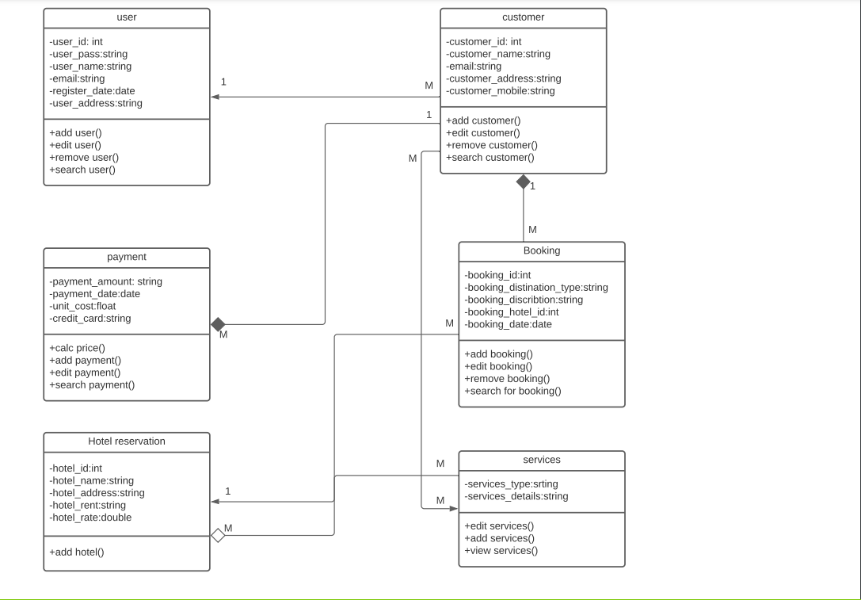

Sequence Diagram: -

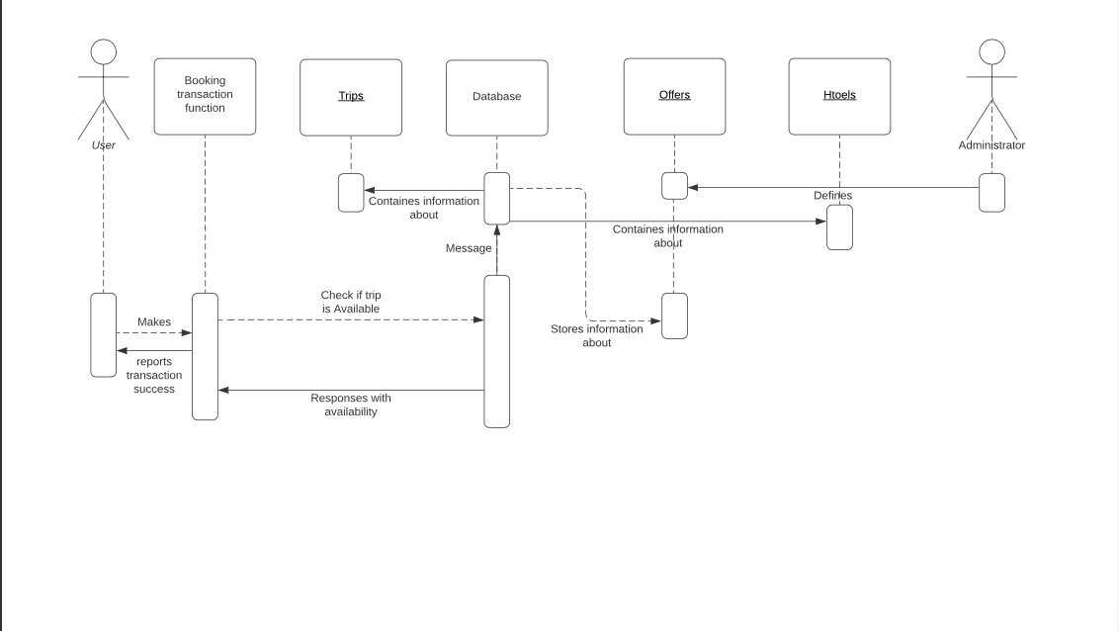

useCase Diagram: 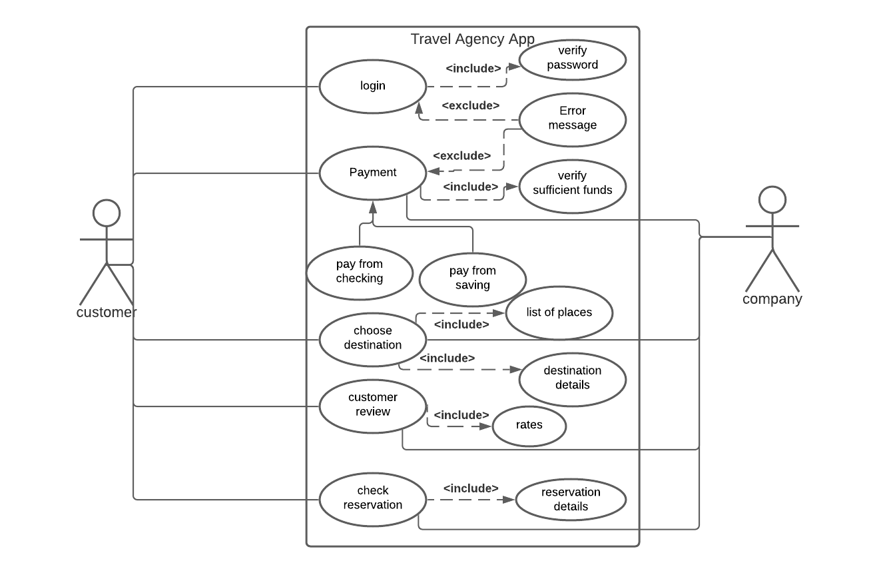

Test Techniques: -

Test Technique:

**Interface testing** we use it to detect faults due to interface errors or invalid assumptions.

* + It detect and check the availability of all texts, images, titles, hyperlinks, bookmark text and graphics of website of our project.
  + Each link should be checked that it works correctly and go to correct destination.
  + Check that all graphics and pictures are loaded successfully.
  + Check the response of any operation on website interface.
  + Check font of text and titles with the correct size and colors.
  + Input fields: ask information from clients. Some of them can be left blank and some can’t. has to verify the right behavior associated with them.

**Validation and verification testing** to check the validity of login page

* + check whether the login works with correct credentials.
  + check that it doesn't work with wrong credentials.
  + check text field limits - whether the browser accepts more than the allowed database limits.
  + check whether password text is hidden.

Security Testing.

**Security testing** It makes sure the website won’t allow unauthorized access to any of its resources that could break the site itself and it ensures that the sensitive information of clients is safe and won’t cause any social or financial damage to its users.

* + Each client in our website won’t be able to access any information of other client.

**Acceptance test** Acceptance testing, a testing technique performed to determine whether or not the software system has met the requirement specifications. The main purpose of this test is to evaluate the system's compliance with the business requirements

Test cases: -

|  |  |  |  |
| --- | --- | --- | --- |
| Test Case Id | Description | Expected Output | Actual output |
| 1 | User ID and password are blank | “Enter the user ID and Password”  Error message should be displayed | Message Displayed |
| 2 | User ID is blank | “Enter the user ID”  Error message should be displayed | Message Displayed |
| 3 | Password is blank | “Enter the password”  Error message should be displayed | Message Displayed |
| 4 | Wrong ID | “This ID is invalid”  Error message should be displayed | Message Displayed |
| 5 | Wrong password | “Password is incorrect, please enter correct password”  Error message should be displayed | Message Displayed |
| 6 | Correct user ID and password | The main form should be displayed, and login history data should be saved in the database | The main form displayed and saved in the database |
| 7 | Press “forget password” button | Forget password form should be displayed | Forget password form displayed |